MBA Leadership Report Generation

**Background**

There are 4 MBA Programs:

University City MBA  
Full-Time MBA  
Online MBA  
Malvern MBA (Vanguard MBA also here)

There is one course that uses the survey:

ORGB 511: Leading in Dynamic Environments

Unit 2: Self-Awareness & Career Management

Unit 3: Building & Leveraging Social Networks   
Unit 4: Leadership and Motivation - Values, Vision and Empowerment  
Unit 6: Ethical Leadership

Unit 9: Leading High-Performance Teams

There is one Survey, administered through Qualtrics, following the naming convention:

1. LeBow Leadership Development Survey, QUARTER ACADEMIC YEAR

-All students in all 4 MBA Programs take the MBA Survey, QUARTER ACADEMIC YEAR.

**Survey**

To access the survey login to DrexelOne, click the CAMPUS+COMMUNITY tab. A link to Qualtrics is available under ‘Technology Services’.

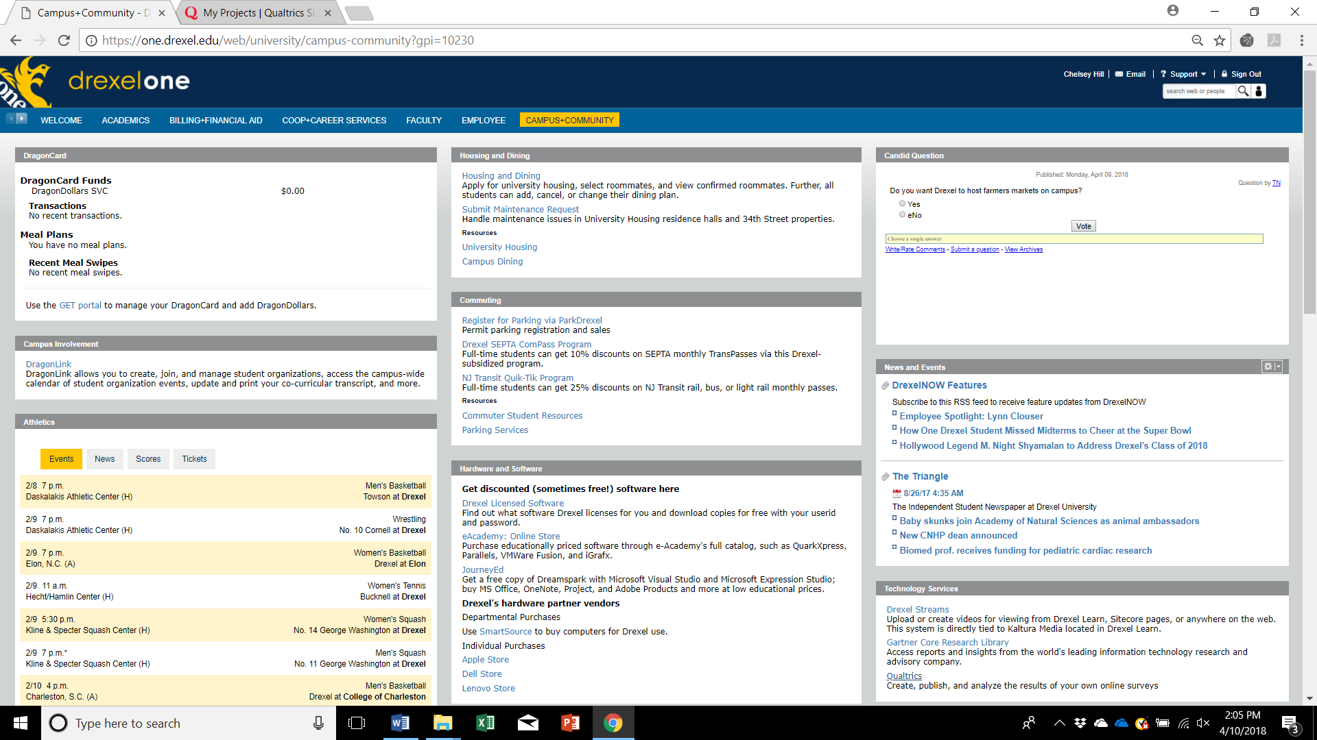

**Create the Survey**

To create a new survey that is a duplicate of an existing survey, choose the dropdown for that survey and choose ‘Copy Project’. Rename, updating the Academic Year and Quarter.

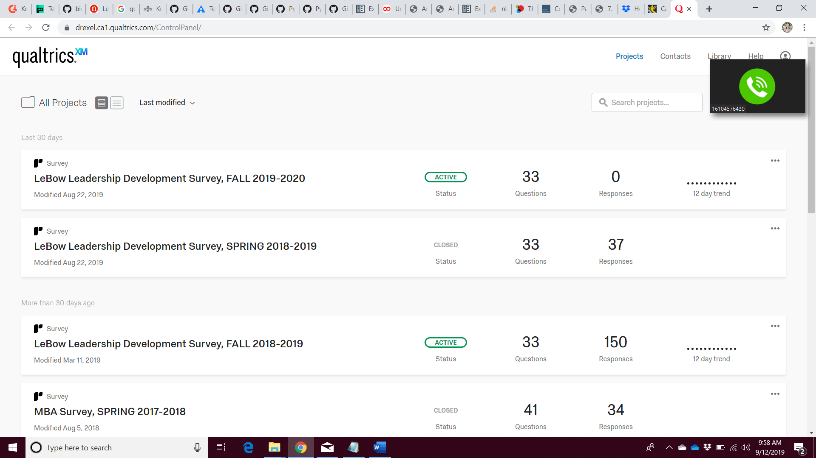

**Create Survey Distribution Link**

To distribute the survey and generate the link to the survey, choose distributions:

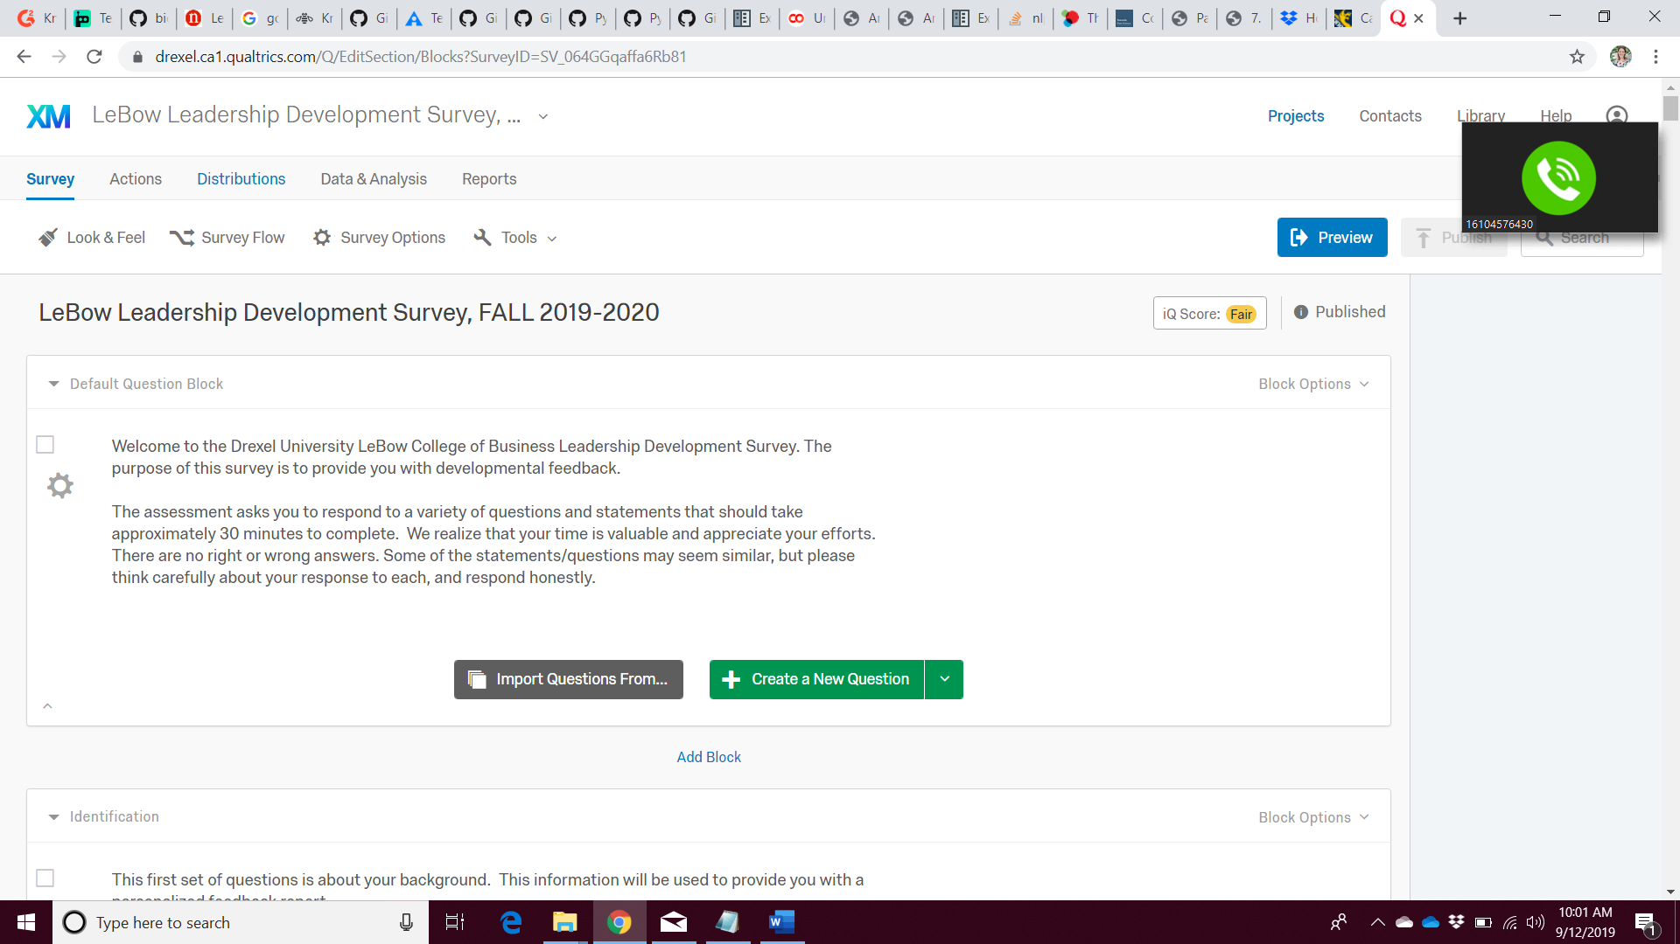

Choose the ‘Anonymous Link’ tab and copy the anonymous survey link.

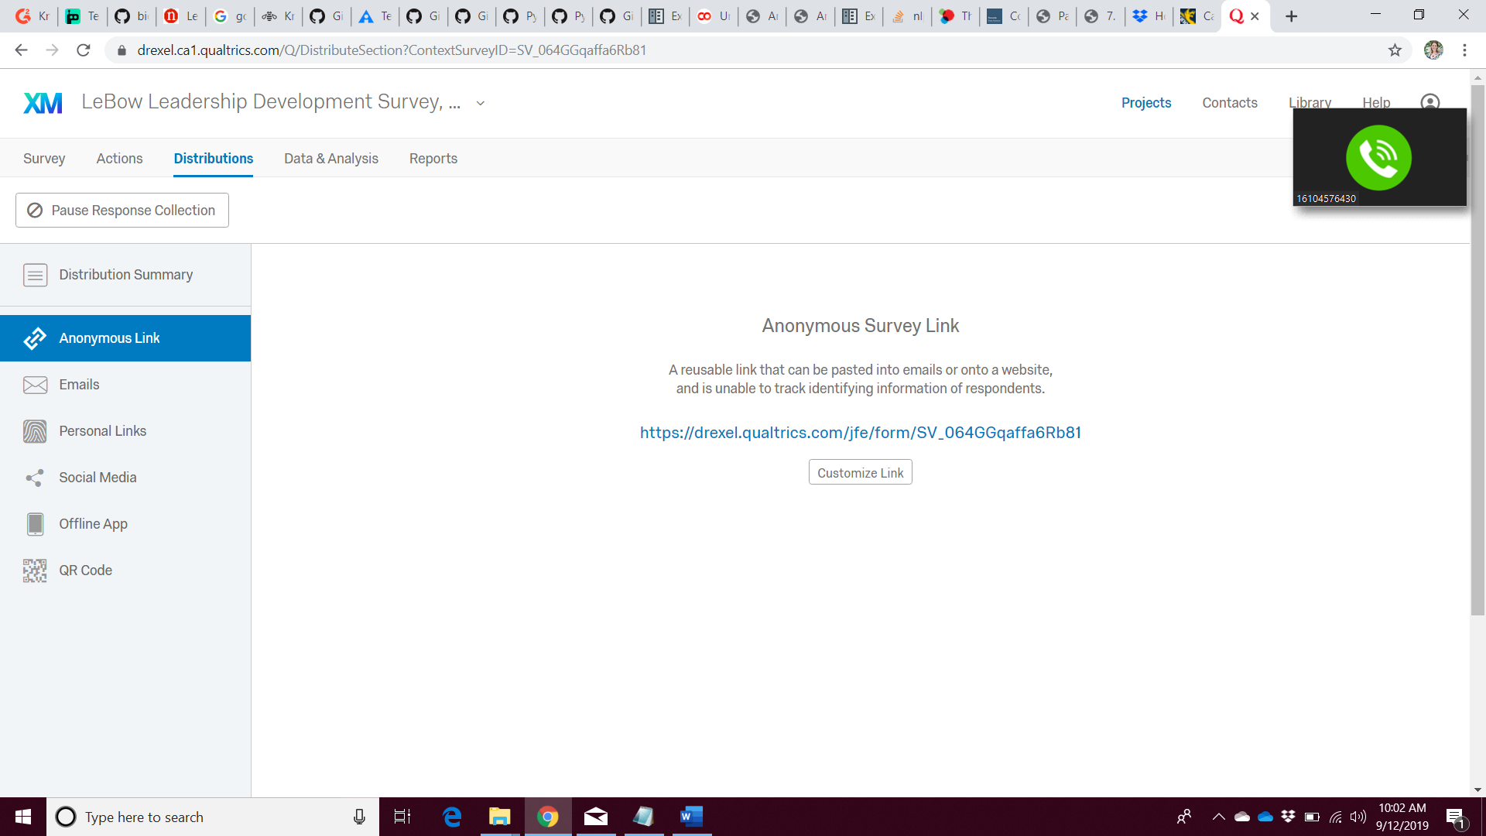

**Open and Close the Survey**

On the Survey homepage, under the Survey tab, click ‘Survey Options’:

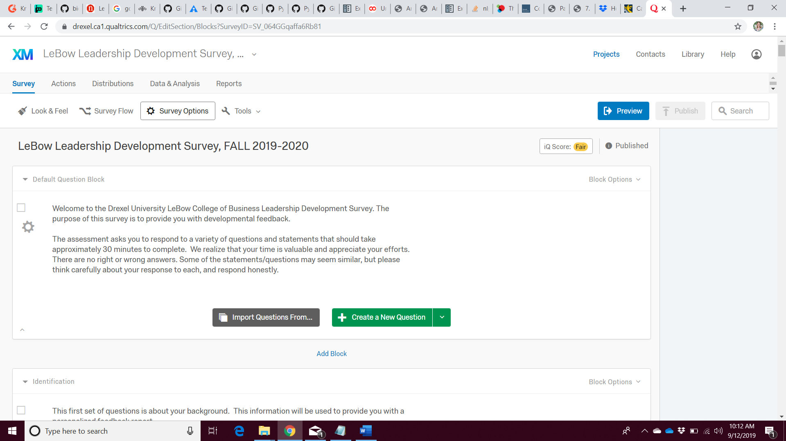

Under Survey Protection, change the ‘Survey Expiration’ information to reflect the survey open and close date.

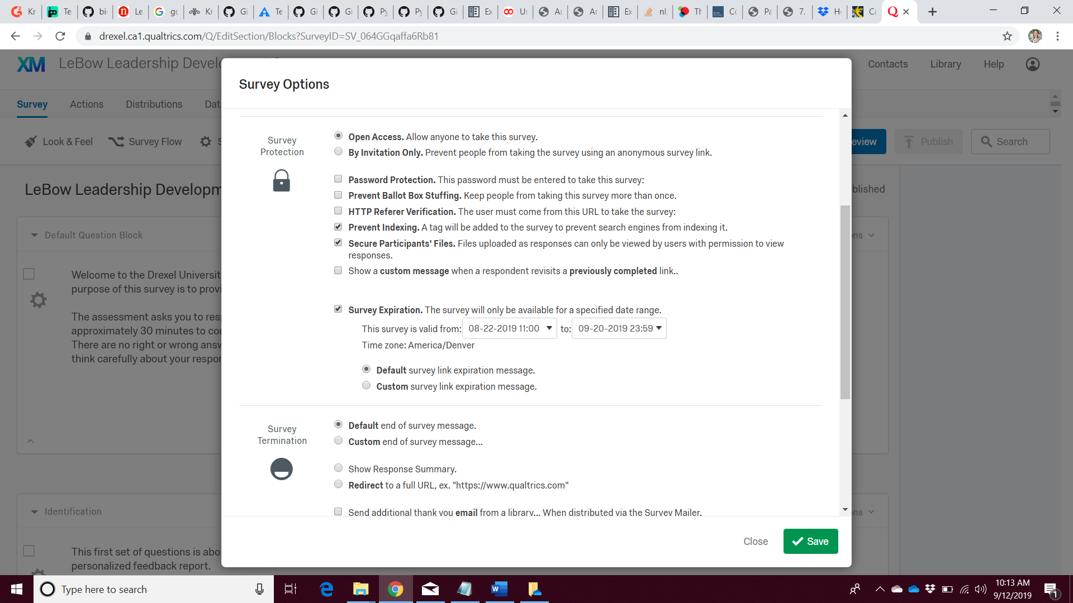

On the day that the survey closes, navigate to the Project homepage. For the survey you wish to permanently close, choose ‘Close’ from the drop down. The status will change from Active to Closed. Choose to close any outstanding (unfinished) surveys.



**Export the Survey Data**

On the survey page, navigate to the Data & Analysis tab. Choose ‘Export & Import’. Then, click ‘Export Data’:

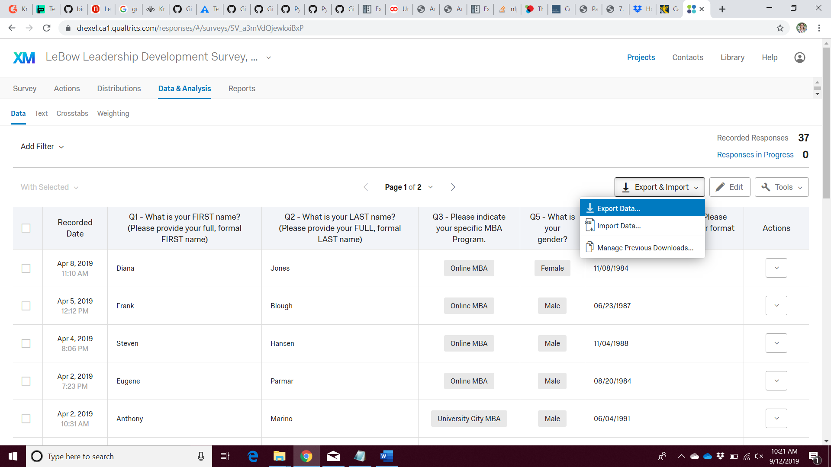

On the ‘Download Data Table’ window that pops up, choose CSV. Choose the bubble to use numeric fields and click ‘Download’.

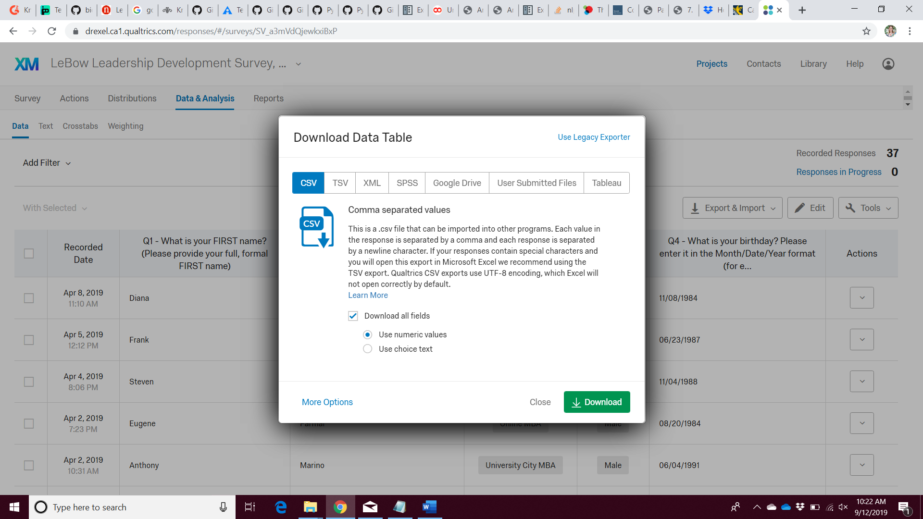

**Data Cleaning & Preprocessing**

-Remove the second and third rows of the survey data.

-Identify empty or unfinished survey submissions. Remove empty rows and leave unfinished—the R code will determine if they have met the threshold level to receive a personalized report.  
These are easy to identify, because they will have missing information in the LocationLatitude and LocationLongitude fields and the Finished field will have a value of 0.

-Identify duplicate surveys and keep the most complete survey. If both are complete, choose a submission and remove the other. The R code will also identify duplicates.

-Identify misspellings, formal v. informal names, etc. If informal or nickname information is provided in the survey that does not match the course roster information, change the name to match the course list.

-Triangulate the participant information with the list of MBA students. Add their class section information from the list provided by the Graduate Office. This should be added in the column for the ‘DistributionChannel’ field (keep the column name as DistributionChannel, but replace the contents with the Section information.

-Create a list of any individuals who did not take the survey, so that their generic reports can be generated. This information can be input to the ‘Nonparts_Template.csv’ file to import into R.

**R Analysis**

The files needed to perform the analysis include:

-R File (MBA_Code.R)  
-Qualtrics data CSV file (exported from Qualtrics and saved locally)  
-The data dictionary (DD_Fall 2018_2019.csv)  
-Sequence information (MBA_Cat_Seq1.csv)  
-Filled-in Nonparticipant information (Nonparts_Template.csv)

**Report Generation**

Before beginning, create folder hierarchies on your computer. The main folders are by section, as shown below:

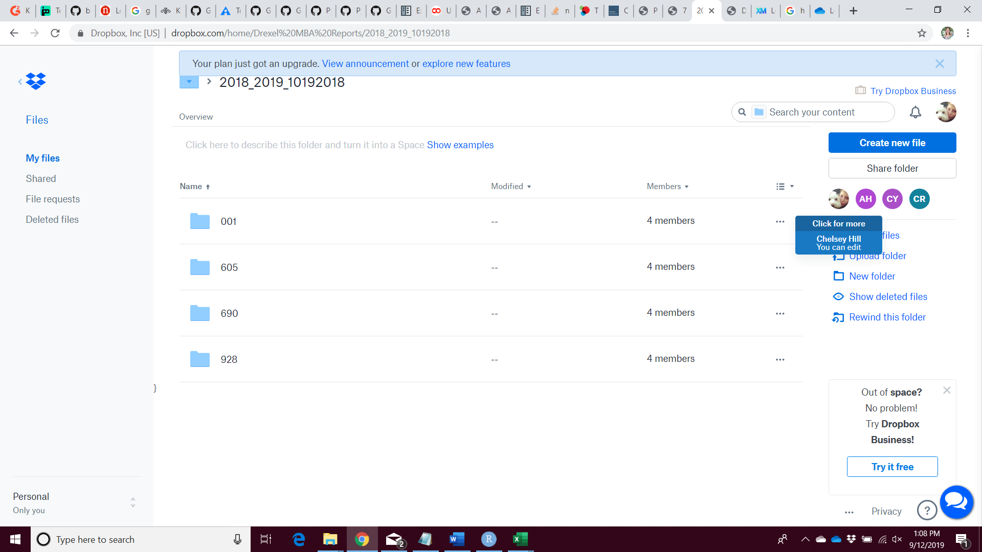

In each folder, you will create folders for each Section. An example of these folders for Section 001 is below. Note: You will make folders in each of the section folders with the following names: Unit 2, Unit 3, Unit 5, Unit 7, and Unit 9.

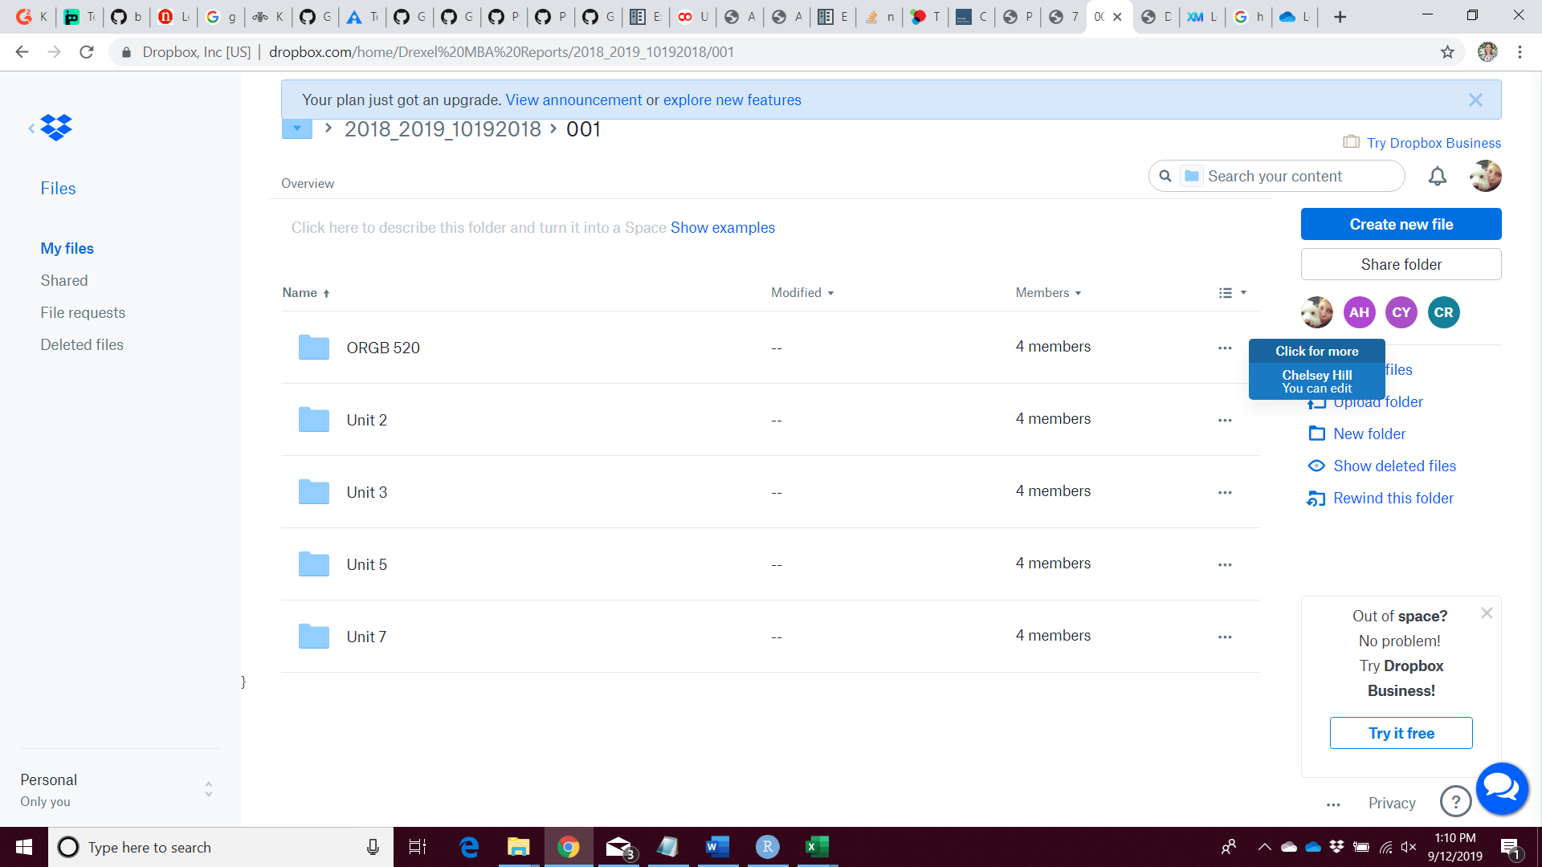

Reports are generated using the ‘MBA_Reporting_Project.xlsm’ file. **You must enable macros to use it**. To view VBA modules being run, navigate to the Developer tab.

There are 3 worksheets used in the report generation:

-MBA: used to add the data and set-up the selection box on the Fellows Charts tab.  
-Fellows Charts: used to choose the names to generate the reports  
-Fellows Reports: The report template

On the MBA sheet:

1. Copy and paste the csv file data created in the final R code line beginning in cell A1.
2. Copy the Full Name and Section columns to one of the extra sheets and remove duplicates.
3. Remove Average entities.
4. Paste the name and section information beginning in cell L22. This sets up the box on the Fellows Charts tab.
5. Delete (or move to column H) the Section Column. The columns should be:  
   A: First_Name  
   B: Last_Name  
   C: Full_Name  
   D: Program  
   E: variable  
   F: value  
   G: Type

To reset the range for the dropdown box based on the input beginning in L22, navigate to the Fellows Chart worksheet:

1. Right click on the dropdown box.
2. Choose ‘Format Control’

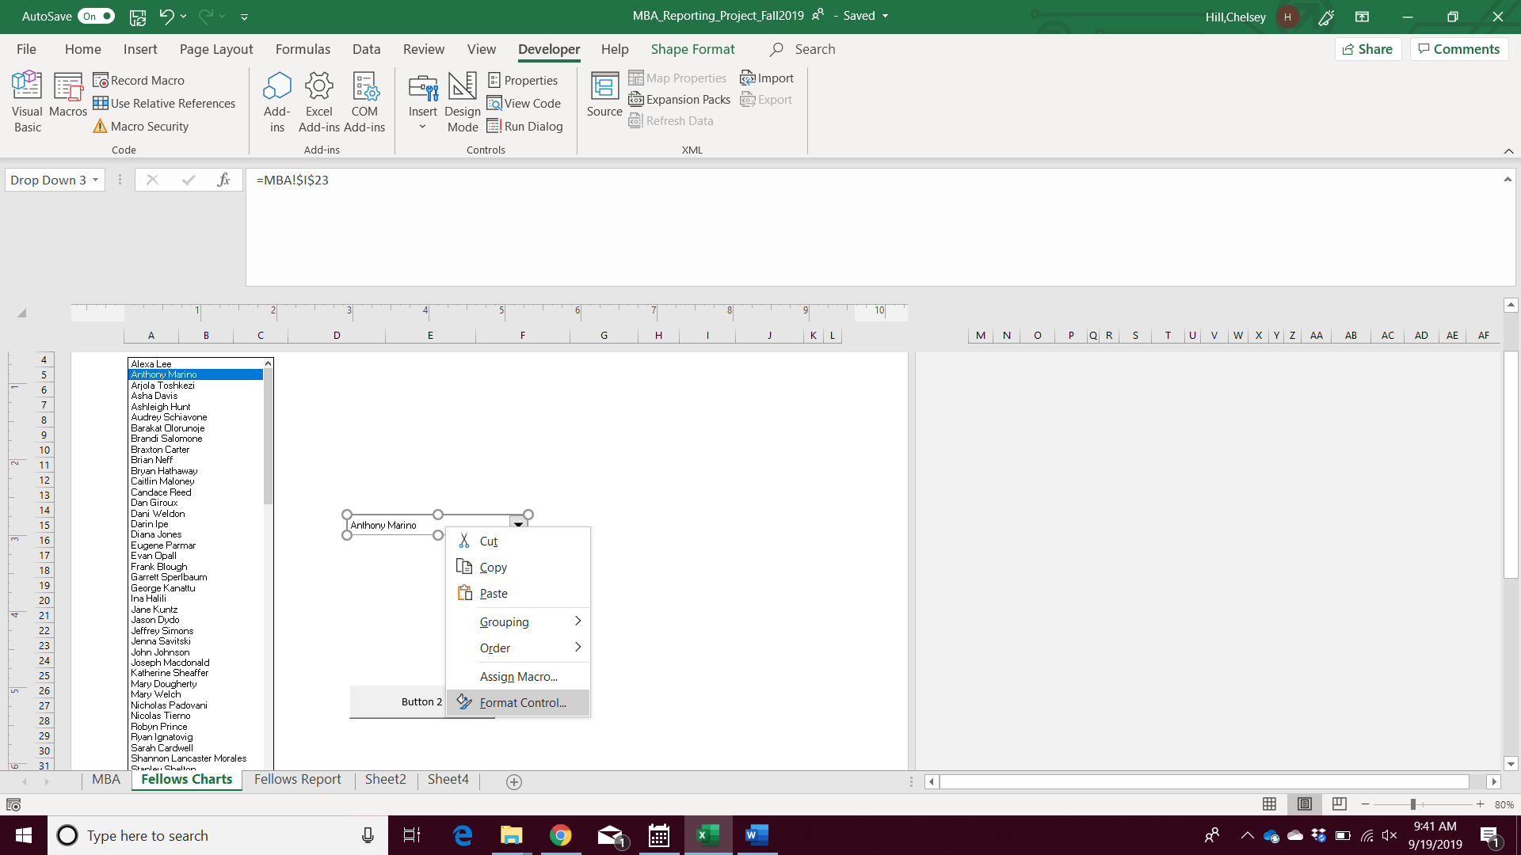

1. Update the input range based on the MBA worksheet beginning in cell L22:

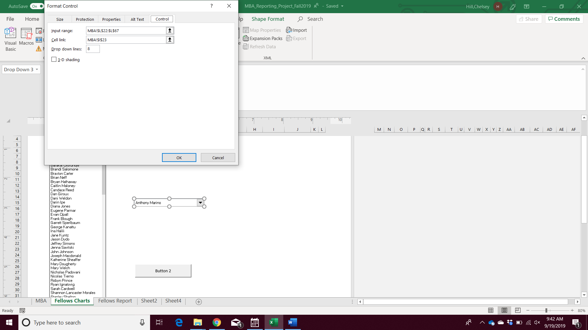

To update the file path locations for the reports to generate to on your computer:

On the Developer Tab, Choose Visual Basic:

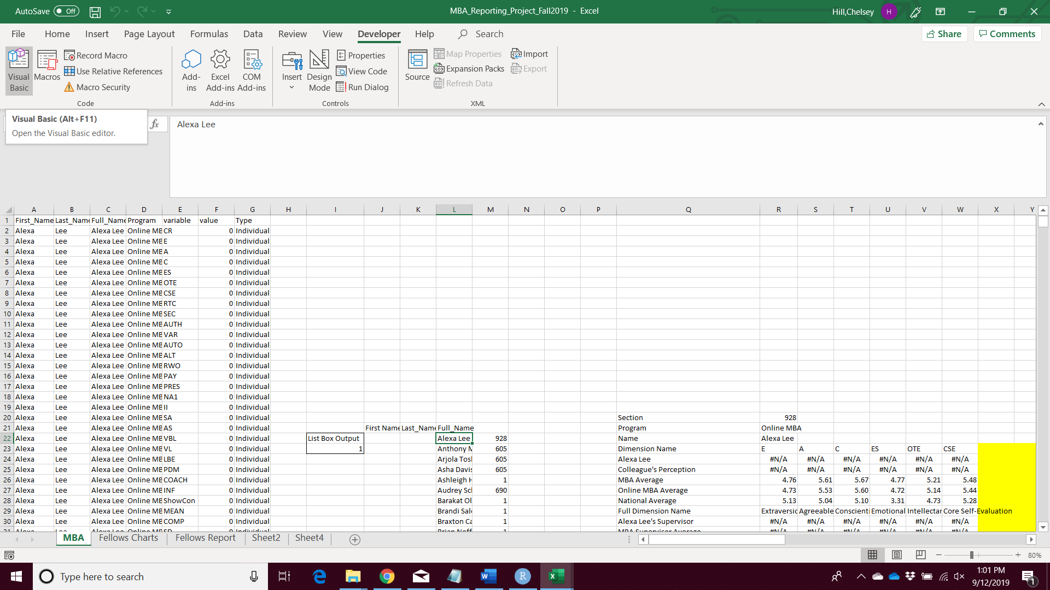

When the Visual Basic Window opens, navigate to ‘Modules’:

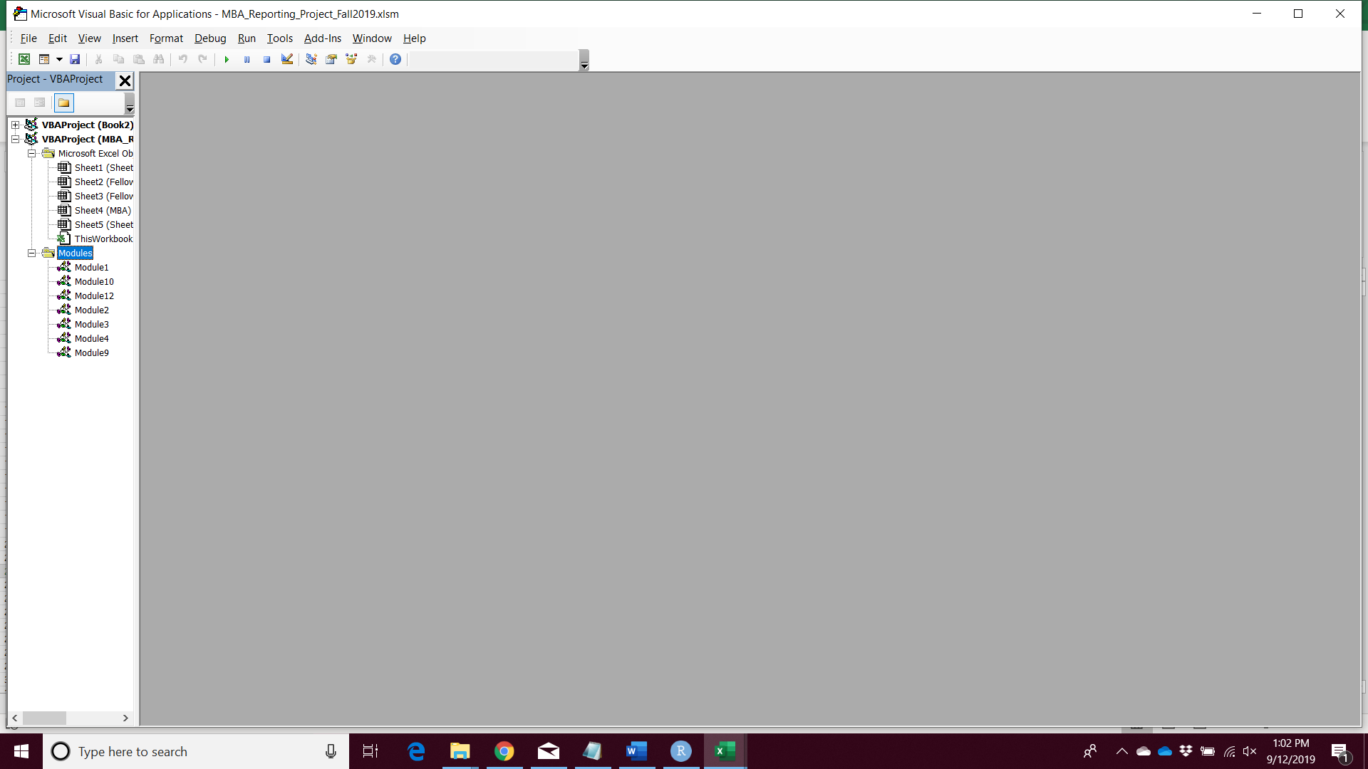

Module 1: Sets up the Footers and works the Listbox  
Module 10: Set up navigation for prior iterations, deprecated  
Module 12: Sets up Listbox click action  
Module 2: Set up navigation for prior iterations, deprecated  
Modules 3 & 4: Create the charts based on the input from the ListBox  
Module 9: Sets up automatic directory locations by Section when reports are generated

Open Module 9 and do the following:

-Update the section information to reflect the section numbers used in your reporting iteration. This is done by updating the following code:  
  
If Sheet4.Range("R20").Value = "1" Then

Folder = "001"

ElseIf Sheet4.Range("R20").Value = "605" Then

Folder = "605"

ElseIf Sheet4.Range("R20").Value = "690" Then

Folder = "690"

ElseIf Sheet4.Range("R20").Value = "928" Then

Folder = "928"

ElseIf Sheet4.Range("R20").Value = "929" Then

Folder = "929"

Else

Folder = "510"

End If

-For each of the code lines that starts with ‘Filename:=’, update "C:\Users\hillc\Dropbox\Fellows Reporting Project\Fall2018_2019\Reports\" to point to the location of the empty folders you created. There is a code line for each unit and there are 5 units. Be sure to update each of the lines.

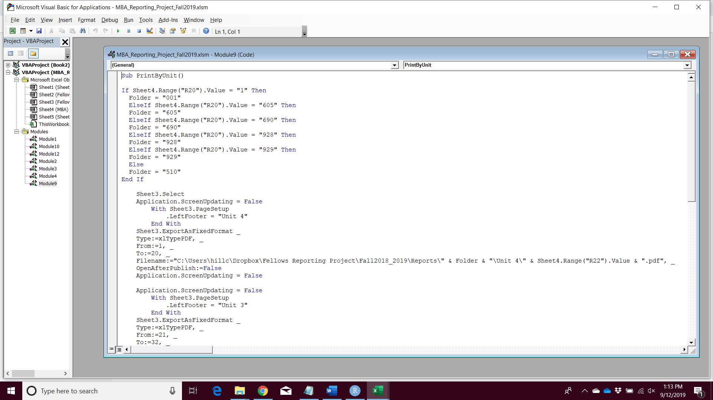

Navigate to the Fellows Charts worksheet. Choose the participant whose report you would like to generate from the List Box. You can navigate to the Fellows Report tab to ensure that their report is displayed. (Note: the footers will update when the reports are ‘printed’ to file)

Return to the Fellows Charts worksheet. Click ‘Button 2’ to save the report to the appropriate folder.

Afterwards, there should be one file for each unit for the participant in their section, unit files. Confirm that the files are in the correct folders and rendered correctly.

Once confirmed, repeat the list box choice and button 2 clicking for all survey participants.